

Service Integration

Low Level Design

For AJSK

Details the ESB design for integrating AJSK Service

Version : V0.1

**Document Control**

|  |  |
| --- | --- |
| **Document Information** | |
| *Document Name* | *Low Level Design Document* |
| *Client* | *Department of e-Governance, Government of Karnataka* |
| *Document Author(s)* | *Prashanth Nuggehalli Chandrashekar* |
| *Document Version* | *V0.1* |
| *Document Status* | *Ready for Reiview* |
| *Date Last Update* | *7th July 2021* |
| *Date Released* | *12-July-2021* |

**Document Edit History**

|  |  |  |  |
| --- | --- | --- | --- |
| **Version** | **Date** | **Additions/Modifications** | **Prepared / Revised by** |
| V0.1 | 12th Jul 2021 | Initial Draft | Prashanth Chandrashekar |
|  |  |  |  |
|  |  |  |  |
|  |  |  |  |

**Document Review/Approval History**

|  |  |  |  |  |
| --- | --- | --- | --- | --- |
| **#** | **Name**  ***(Prepared By)*** | **Organization/Title**  ***(Approved By)*** | **Date**  ***(Approval Date)*** | **Comments**  ***(Description)*** |
|  |  |  |  |  |
|  |  |  |  |  |
|  |  |  |  |  |
|  |  |  |  |  |

*This page is intentionally left blank*

**Table of Contents**

**Introduction** **6**

**API Implementation Diagram** **6**

**Participating API Endpoints** **6**

**Input Output** **7**

**XAPI (Experience API)** **7**

**PAPI (Process API)** **10**

**SAPI (System API)** **14**

# Introduction

This integration is to talk to connect to AJSK service and get the AJSK details. The below mentioned diagram shows the context in which the API is implemented and how the conection is established to the participating services in the integration.

## API Implementation Diagram

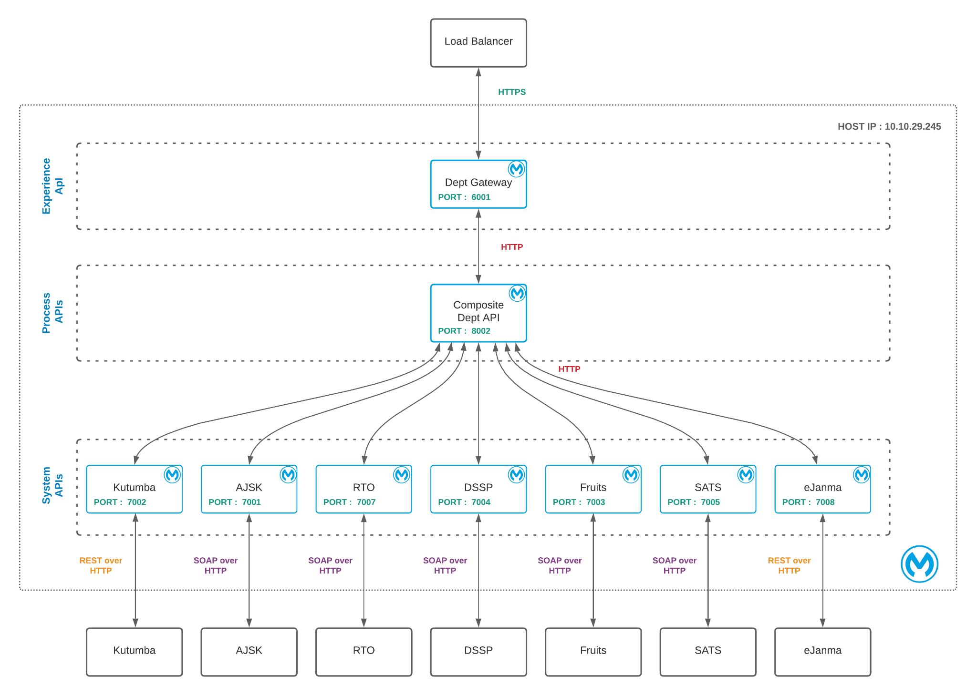

# Participating API Endpoints

|  |  |  |  |  |
| --- | --- | --- | --- | --- |
| **#** | **Name** | **URI/URL** | | |
| 1 | XAPI | http://10.10.29.245:6001/api/department/data/single | | |
| 2 | PAPI | http://10.10.29.245:8002/esb/fdb/department/single | | |
| 3 | SAPI | http://10.10.29.245:7001/esb/kutumba/GetDepartment | | |
| 4 | Destination | https://nadakacheri.karnataka.gov.in/sms_ws/WebService.asmx | | |

* XAPI Invokes >> PAPI
* PAPI Invokes >> SAPI
* SAPI Invokes >> Destination Service
* Response from Destination Service is passed to the respective callers

# Input Output

### XAPI (Experience API)

|  |  |  |
| --- | --- | --- |
| Request | | |
| {  "deptId":2,  "input":{  "rdNumber":"RD0034130083004"  },  "method":"GetXmlDataWoDSC",  "creds":{  "client-id":"1234567",  "client-secret":"7654321"  }  } | | |
| Response | | |
| {  "GetXmlDataWoDSC": {  "GetXmlDataWoDSCVResponse": {  "GetXmlDataWoDSCVResult": {  "SMSWSOP": {  "Status": "1",  "StatusMsg": "Valid Certificate",  "FacilityCode": "8",  "FacilityName": "Caste Certificate (SC/ST)",  "Language": "99",  "xmlData":  "<CasteCertificate><ApplicantDetails><GSCNo>RD0034130083004</GSCNo><TLIFileNo>CC(  SCST)CR/Aurad  B/30/2018-2019</TLIFileNo><DistrictName>Bidar</DistrictName><TalukName>Aurad</Tal  ukName><HobliName>Aurad  B</HobliName><VillageName>Aurad  B</VillageName><HabitationName>Gandhichowka</HabitationName><VillageWardLabel>War  d</VillageWardLabel><App_Title>Sri.</App_Title><ApplicantName>AMAR</ApplicantName  ><ApplicantBincom>S/O</ApplicantBincom><Fat_Title>Sri.</Fat_Title><ApplicantFathe  rName>GANPATI</ApplicantFatherName><ApplicantMotherName>RENUKA</ApplicantMotherNa  me><ApplicantCAddress1>NEAR TIRUMALA SCHOOL AURAD  B</ApplicantCAddress1><ApplicantCAddress2>TQ AURAD B</ApplicantCAddress2><ApplicantCAddress3>DIST BIDAR  </ApplicantCAddress3><ApplicantCAddressPin>585326</ApplicantCAddressPin><Reservat  ionCategory>Scheduled Tribe</ReservationCategory><Caste>Tokre  Koli</Caste><AnnualIncome>11000</AnnualIncome><AnnualIncomeInWords>Rs. eleven  thousand  only.</AnnualIncomeInWords><Photo>../DataImages/Final_RD0034130083004.jpg</Photo>  <Purpose>0</Purpose><DateOfIssue>07/01/2019</DateOfIssue><Version>4.1</Version><B  arcode>../DataImages/BC_RD0034130083004.bmp</Barcode><ValidPeriod>ninety nine  thousand nine hundred ninety nine  </ValidPeriod><SpecialTaluk>N</SpecialTaluk><SignerName>M  CHANDRASHEKAR</SignerName><CertificateValidUpto></CertificateValidUpto></Applican  tDetails></CasteCertificate>"  }  }  }  }  } | | |
| Error | | |
| **Sample 1**   * As is Error Propagation from down stream service (This means whatever the destination service throws)   **Sampe 2**  {  "httpCode": "403",  "errorType": {  "parentErrorType": {  "parentErrorType": **null**,  "identifier": "ANY",  "namespace": "MULE"  },  "identifier": "INCORRECT_CREDS",  "namespace": "AJASK-CONSUMER-SYS"  },  "error": "AJASK API Authentication Failure : Client Id and Client Secret does not match !",  "correlation": "7889e840-e3bd-11eb-b574-02429ea494eb"  } | | |

### PAPI (Process API)

|  |  |  |
| --- | --- | --- |
| Request | | |
| {  "deptId":2,  "input":{  "rdNumber":"RD0034130083004"  },  "method":"GetXmlDataWoDSC",  "creds":{  "client-id":"1234567",  "client-secret":"7654321"  }  } | | |
| Response | | |
| {  "GetXmlDataWoDSC": {  "GetXmlDataWoDSCVResponse": {  "GetXmlDataWoDSCVResult": {  "SMSWSOP": {  "Status": "1",  "StatusMsg": "Valid Certificate",  "FacilityCode": "8",  "FacilityName": "Caste Certificate (SC/ST)",  "Language": "99",  "xmlData":  "<CasteCertificate><ApplicantDetails><GSCNo>RD0034130083004</GSCNo><TLIFileNo>CC(  SCST)CR/Aurad  B/30/2018-2019</TLIFileNo><DistrictName>Bidar</DistrictName><TalukName>Aurad</Tal  ukName><HobliName>Aurad  B</HobliName><VillageName>Aurad  B</VillageName><HabitationName>Gandhichowka</HabitationName><VillageWardLabel>War  d</VillageWardLabel><App_Title>Sri.</App_Title><ApplicantName>AMAR</ApplicantName  ><ApplicantBincom>S/O</ApplicantBincom><Fat_Title>Sri.</Fat_Title><ApplicantFathe  rName>GANPATI</ApplicantFatherName><ApplicantMotherName>RENUKA</ApplicantMotherNa  me><ApplicantCAddress1>NEAR TIRUMALA SCHOOL AURAD  B</ApplicantCAddress1><ApplicantCAddress2>TQ AURAD B</ApplicantCAddress2><ApplicantCAddress3>DIST BIDAR  </ApplicantCAddress3><ApplicantCAddressPin>585326</ApplicantCAddressPin><Reservat  ionCategory>Scheduled Tribe</ReservationCategory><Caste>Tokre  Koli</Caste><AnnualIncome>11000</AnnualIncome><AnnualIncomeInWords>Rs. eleven  thousand  only.</AnnualIncomeInWords><Photo>../DataImages/Final_RD0034130083004.jpg</Photo>  <Purpose>0</Purpose><DateOfIssue>07/01/2019</DateOfIssue><Version>4.1</Version><B  arcode>../DataImages/BC_RD0034130083004.bmp</Barcode><ValidPeriod>ninety nine  thousand nine hundred ninety nine  </ValidPeriod><SpecialTaluk>N</SpecialTaluk><SignerName>M  CHANDRASHEKAR</SignerName><CertificateValidUpto></CertificateValidUpto></Applican  tDetails></CasteCertificate>"  }  }  }  }  } | | |
| Error | | |
| **Sample 1**   * As is Error Propagation from down stream service (This means whatever the destination service throws)   **Sampe 2**  {  "httpCode": "403",  "errorType": {  "parentErrorType": {  "parentErrorType": **null**,  "identifier": "ANY",  "namespace": "MULE"  },  "identifier": "INCORRECT_CREDS",  "namespace": "AJASK-CONSUMER-SYS"  },  "error": "AJASK API Authentication Failure : Client Id and Client Secret does not match !",  "correlation": "7889e840-e3bd-11eb-b574-02429ea494eb"  } | | |

### SAPI (System API)

|  |  |  |
| --- | --- | --- |
| Request | | |
| {  "rdNumber":"RD0034130083004"  } | | |
| Response | | |
| <?xml version="1.0" encoding="utf-8"?>  <soap:Envelope xmlns:soap="http://www.w3.org/2003/05/soap-envelope" xmlns:xsi="http://www.w3.org/2001/XMLSchema-instance" xmlns:xsd="http://www.w3.org/2001/XMLSchema">  <soap:Body>  <GetXmlDataWoDSCVResponse xmlns="http://tempuri.org/">  <GetXmlDataWoDSCVResult>  <SMSWSOP xmlns="">  <Status>1</Status>  <StatusMsg>Valid Certificate</StatusMsg>  <FacilityCode>8</FacilityCode>  <FacilityName>Caste Certificate (SC/ST)</FacilityName>  <Language>99</Language>  <xmlData>&lt;CasteCertificate&gt;&lt;ApplicantDetails&gt;&lt;GSCNo&gt;RD0034130083004&lt;/GSCNo&gt;&lt;TLIFileNo&gt;CC(SCST)CR/Aurad B/30/2018-2019&lt;/TLIFileNo&gt;&lt;DistrictName&gt;Bidar&lt;/DistrictName&gt;&lt;TalukName&gt;Aurad&lt;/TalukName&gt;&lt;HobliName&gt;Aurad B&lt;/HobliName&gt;&lt;VillageName&gt;Aurad B&lt;/VillageName&gt;&lt;HabitationName&gt;Gandhichowka&lt;/HabitationName&gt;&lt;VillageWardLabel&gt;Ward&lt;/VillageWardLabel&gt;&lt;App_Title&gt;Sri.&lt;/App_Title&gt;&lt;ApplicantName&gt;AMAR&lt;/ApplicantName&gt;&lt;ApplicantBincom&gt;S/O&lt;/ApplicantBincom&gt;&lt;Fat_Title&gt;Sri.&lt;/Fat_Title&gt;&lt;ApplicantFatherName&gt;GANPATI&lt;/ApplicantFatherName&gt;&lt;ApplicantMotherName&gt;RENUKA&lt;/ApplicantMotherName&gt;&lt;ApplicantCAddress1&gt;NEAR TIRUMALA SCHOOL AURAD B&lt;/ApplicantCAddress1&gt;&lt;ApplicantCAddress2&gt;TQ AURAD B &lt;/ApplicantCAddress2&gt;&lt;ApplicantCAddress3&gt;DIST BIDAR &lt;/ApplicantCAddress3&gt;&lt;ApplicantCAddressPin&gt;585326&lt;/ApplicantCAddressPin&gt;&lt;ReservationCategory&gt;Scheduled Tribe&lt;/ReservationCategory&gt;&lt;Caste&gt;Tokre Koli&lt;/Caste&gt;&lt;AnnualIncome&gt;11000&lt;/AnnualIncome&gt;&lt;AnnualIncomeInWords&gt;Rs. eleven thousand only.&lt;/AnnualIncomeInWords&gt;&lt;Photo&gt;../DataImages/Final_RD0034130083004.jpg&lt;/Photo&gt;&lt;Purpose&gt;0&lt;/Purpose&gt;&lt;DateOfIssue&gt;07/01/2019&lt;/DateOfIssue&gt;&lt;Version&gt;4.1&lt;/Version&gt;&lt;Barcode&gt;../DataImages/BC_RD0034130083004.bmp&lt;/Barcode&gt;&lt;ValidPeriod&gt;ninety nine thousand nine hundred ninety nine &lt;/ValidPeriod&gt;&lt;SpecialTaluk&gt;N&lt;/SpecialTaluk&gt;&lt;SignerName&gt;M CHANDRASHEKAR&lt;/SignerName&gt;&lt;CertificateValidUpto&gt;&lt;/CertificateValidUpto&gt;&lt;/ApplicantDetails&gt;&lt;/CasteCertificate&gt;</xmlData>  </SMSWSOP>  </GetXmlDataWoDSCVResult>  </GetXmlDataWoDSCVResponse>  </soap:Body>  </soap:Envelope> | | |
| Error | | |
| Propogated Errors from Downstream Application Services or Destination Services | | |